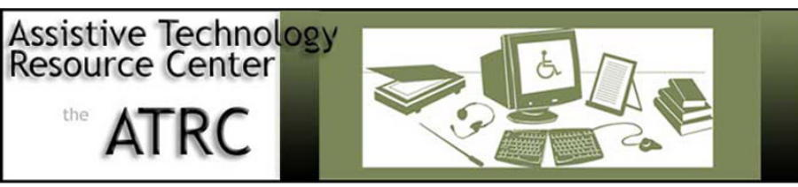
AT Services Update/ Spring 09:
Charges for Technology Meeting

- AT/IT support and Web access support –
- please utilize ATRC for web accessibility assistance – refer others as appropriate
- Jesse Hausler ( 491-0625; jhausler@cahs.colostate.edu)

- Laptop pilot project – tabled due to difficulties with remote access with AT software
- ATRC will receive surplused library laptops
- Continue to explore feasibility of remote access

- Tech Fee Expenditures
- extended spending deadline beyond April 1st
- Add 20% to current year totals
- Tech fee expenditures request will come from OEOD vs. VPSA

- AT expenditures for July 2007 – June 2008
- Upgrades or initial acquisition of the following AT software applications:
- Easy Reader Site License
- Duxbury Braille Translation software
- WYNN – text to speech software – network upgrade and SMA
- CS3 Design Standard License

- Hardware accommodations:
- Axim 5.1 Handheld
- Tiger Max graphics and Braille embosser & floor stand
- Computers for library AT rooms
- Think pad – tablet computer
- Roller mouse pointing device

- Peripherals/Accessories:
- Array Microphone
- Digital Recorders
- Braille Paper
- Paper for library AT rooms
- Keyboard protection covers
- I-talk pro USB microphones (4)
Marla C. Roll, MS, OTR
Director, Assistive Technology Resource Center / Assist Professor, Dept of Occupational Therapy
mcroll@cahs.colostate.edu ; 491-2016

